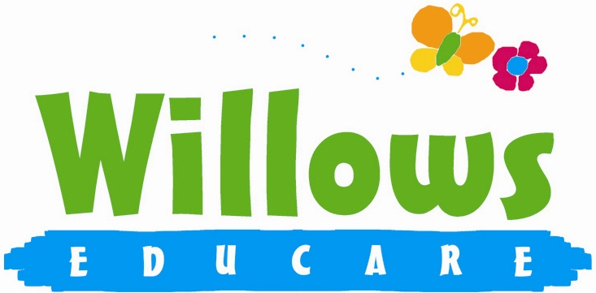

Promoting health and hygiene

1.20 First aid

Policy statement

In our setting staff are able to take action to apply first aid treatment in the event of an accident involving a child or adult. At least one member of staff with current first aid training is on the premises or on an outing at any one time. The first aid qualification includes first aid training for infants and young children.

EYFS key themes and commitments
A Unique Child | Positive Relationships | Enabling Environments | Learning and Development
1.3 Keeping safe  1.4 Health and well-being | 2.2 Parents as partners  2.4 Key person | 3.2 Supporting every child  3.4 The wider context

Procedures

The First Aid Kit
- The first aid box is easily accessible to adults and is kept out of the reach of children.
- No un-prescribed medication is given to children, parents or staff.
- All stock is regularly checked to ensure it is in date
- At the time of admission to the setting, parents' written permission for emergency medical advice or treatment is sought. Parents sign and date their written approval.
- Parents sign a consent form at registration allowing staff to take their child to the nearest Accident and Emergency unit to be examined, treated or admitted as necessary on the understanding that parents have been informed and are on their way to the hospital.

Legal framework

- Health and Safety (First Aid ) Regulations (1981)

Further guidance

- First Aid at Work: Your questions answered (HSE 1997)
www.hse.gov.uk/pubns/indg214.pdf
- Basic Advice on First Aid at Work (HSE 2006)
www.hse.gov.uk/pubns/indg347.pdf
- Guidance on First Aid for Schools (DfEE)
www.teachernet.gov.uk/_doc/4421/GFAS.pdf

This policy was adopted at a meeting of | Willows Educare
Held on | January 2023
Date to be reviewed | January 2024
Signed on behalf of the management committee
Name of signatory | Susan Oliver
Role of signatory (e.g. chair/owner) | Chair

