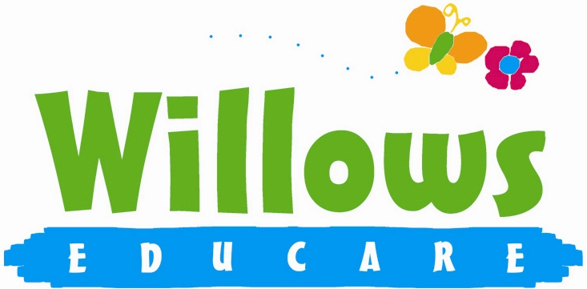
Partnership

4.5 Working in partnership with other agencies

Policy Statement

We work in partnership with local and national agencies to promote the well-being of all children.

EYFS Key themes and commitments

A Unique Child | Positive Relationships | Enabling Environments | Learning and Development
1.3 Keeping safe  1.4 Health and well-being | 2.1 Respecting each other | 3.4 The wider context

Procedures

- We work in partnership or in tandem with, local and national agencies to promote the well-being of children.
- Procedures are in place for sharing of information about children and families with other agencies. These are set out in the Information Sharing Protocol, Safeguarding Children procedures and the Special Educational Needs Procedures.
- Information shared by other agencies with us is regarded as third party information. This is also kept in confidence and not shared without consent from that agency.
- When working in partnership with staff from other agencies, we make those individuals welcome in the setting and their professional roles are respected.
- We follow the protocols for working with agencies, for example on child protection.
- Staff from other agencies do not have unsupervised access to the child they are visiting in the setting and do not have access to any other child(ren) during their visit.
- Our staff do not casually share information or seek informal advice about any named child/family.
- When necessary, we consult with local and national agencies to help us develop understanding of issues facing us and who can provide support and information for parents.
- . We will never share your data with any organisation to use for their own purposes.

This policy was adopted at a meeting of | Willows Educare
Held on | January 2024
Date to be reviewed | January 2025
Signed on behalf of the management committee
Name of signatory | Susan Oliver
Role of signatory (e.g. chair/owner) | Chair

