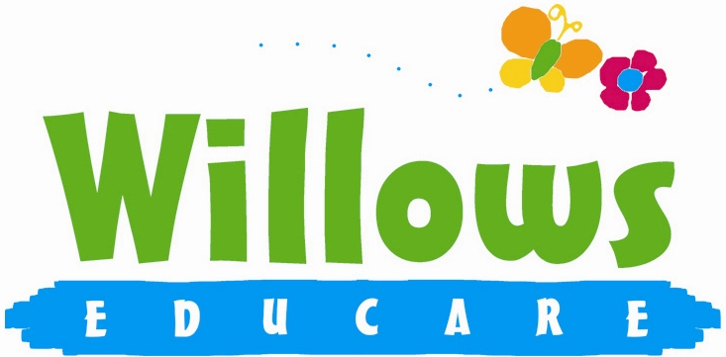

Health and Safety

3.5 Food Hygiene
(Including procedure for reporting food poisoning)

Policy Statement
At Willows we provide and serve food for children on the following basis:
*snacks
*meals

We maintain the highest possible food hygiene standards with regard to purchase, storage, preparation, cooking and serving of food.
We are registered with the Local Authority Environmental Health Department

EYFS key themes and commitments
A Unique Child | Positive Relationships | Enabling Environments | Learning and Development
1.3 Keeping safe |  | 3.3 The learning environment  3.4 The wider context

Procedures
- The person in charge and the person responsible for food preparation understands the principles of Hazard Analysis and Critical Control Point (HACCP) as it applies to their role. This is set out in Safer Food Better Business. The basis for this is risk assessment as it applies to the purchase, storage, preparation and serving of food to prevent growth of bacteria and food contamination.
- All staff follow the guidelines of Safer Food Better Business
- At least one person has an in-date Level 2 Food Hygiene Certificate, and all staff involved in food preparation has Level 1 Food Hygiene Certificate.
- The person responsible for food preparation, cooking and serving carries out daily checks in the kitchen to ensure standards are consistently met.
- We use reliable suppliers for the food we purchase.
- Food is stored at the correct temperatures and is checked to ensure it is in date and not subject to contamination by pests, rodents or mould.
- Packed lunches from home are stored in a cool place, un-refrigerated food is served to children within 4 hours of arriving at Willows.
- Food preparation areas are cleaned before use as well as after use.
- There are separate facilities for hand washing and washing up
- All surfaces are clean and non-porous.
- Utensils, crockery, etc are cleaned and stored appropriately.
- Waste food is disposed of daily.
- Cleaning and other dangerous materials are stored out of the reach of children.
- Children do not have unsupervised access to the kitchen.
- When children take part in cooking activities, they:
are always supervised
understand the importance of hand washing and simple hygiene rules
are kept away from hot surfaces and hot water
do not have access to electrical equipment such as blenders etc.

Reporting of food poisoning
- Food poisoning can occur for several reasons; not all cases of sickness and diarrhoea are because of food poisoning and not all cases of sickness or diarrhoea are reportable.
- Where children and/or adults have been diagnosed by a GP or hospital doctor to be suffering from food poisoning and where it seems possible that the source of the outbreak is within the setting, the manager will contact the Environmental Health Department and the Health Protection Agency, to report the outbreak and will comply with any investigation.
- If the food poisoning is identified as a notifiable disease under the Public Health (infectious Diseases) Regulations 1988 the setting will report the matter to Ofsted.

Legal framework

- Regulation (EC) 852/2004 of the European Parliament and of the Council on the hygiene of foodstuffs

Further guidance

- Safer Food Better Business (Food Standards Agency)
- www.food.gov.uk/foodindustry/regulation/hygleg/hyglegresources/sfbb/sfbbcaterers

This policy was adopted at a meeting of | Willows Educare
Held on | January 2024
Date to be reviewed | January 2025
Signed on behalf of the management committee
Name of signatory | Susan Oliver
Role of signatory (e.g. chair/owner) | Chair

