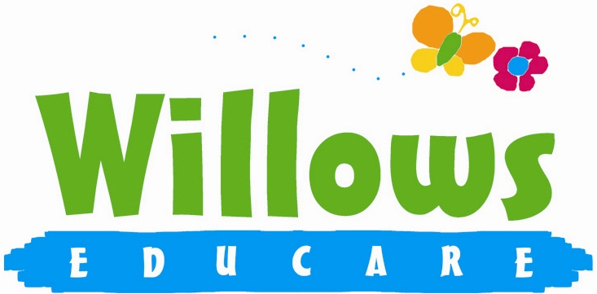

Promoting health and hygiene

1.18 No-smoking/Vaping

Policy statement

We comply with health and safety regulations and the Welfare Requirements of the EYFS in making our setting a no-smoking/no Vaping environment - both indoor and outdoor.

EYFS key themes and commitments
A Unique Child | Positive Relationships | Enabling Environments | Learning and Development
1.4 Health and well-being | 2.1 Respecting each other | 3.2 Supporting every child

Procedures

- All staff, parents and volunteers are made aware of our no-smoking/ non Vaping policy.
- We display no-smoking signs.
- Staff who smoke or Vape do not do so during working hours. Unless on a break and off the premises.

Legal framework

- The Smoke-free (Premises and Enforcement) Regulations 2006
www.opsi.gov.uk/si/si2006/20063368.htm
- The Smoke-free (Signs) Regulations 2007
www.opsi.gov.uk/si/si2007/20070923.htm

This policy was adopted at a meeting of | Willows Educare
Held on | August 2025
Date to be reviewed | August 2026
Signed on behalf of the management committee
Name of signatory | Susan Oliver
Role of signatory | Chair

