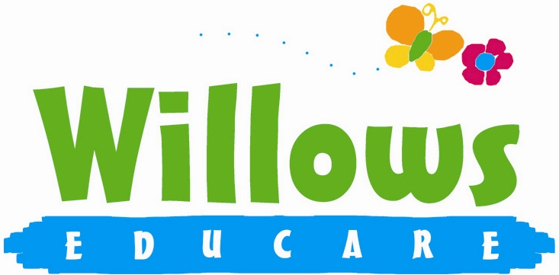

Promoting health and hygiene

1.16 Managing children with allergies, or who are sick or infectious
(Including reporting notifiable diseases eg. Coronavirus)

Policy statement

We provide care for healthy children and promote health through identifying allergies and preventing contact with the allergenic substance and through preventing cross infection of viruses and bacterial infections.

EYFS key themes and commitments

A Unique Child | Positive Relationships | Enabling Environments | Learning and Development
1.2 Inclusive practice  1.4 Health and well-being | 2.2 Parents as partners  2.4 Key person | 3.2 Supporting every child

Procedures for children with allergies

- When parents start their children at Willows they are asked if their child suffers from any known allergies. This is recorded on the enrolment / registration form.
- If a child has an allergy, a Healthcare Plan is completed to detail the following:
- The allergen (i.e. the substance, material or living creature the child is allergic to such as nuts, eggs, bee stings, cats etc).
- The nature of the allergic reactions e.g. anaphylactic shock reaction, including rash, reddening of skin, swelling, breathing problems etc.
- What to do in case of allergic reactions, any medication used and how it is to be used (e.g. Epipen).
- Control measures – such as how the child can be prevented from contact with the allergen.
This form is kept in the child’s personal file and a copy is displayed where staff can see it.
- Parents train staff in how to administer special medication in the event of an allergic reaction.
- Generally, no nuts or nut products are used within the setting.
- Parents are made aware so that no nut or nut products are accidentally brought in, for example to a party.

Insurance requirements for children with allergies and disabilities
- The insurance will automatically include children with any disability or allergy but certain procedures must be strictly adhered to. For children suffering life threatening conditions, or requiring invasive treatments; written confirmation from our insurance provider will be obtained to extend the insurance.

At all times the administration of medication must be compliant with the Welfare Requirements of the Early Years Foundation Stage and follow procedures based on advice given in Managing Medicines in Schools and Early Years Settings (DfEs 2005)

Oral Medication
Asthma inhalers are now regarded as "oral medication" insurers do not need to be notified.
- Oral medications must be prescribed by a GP or have manufacturer’s instructions clearly written on them.
- The setting, Willows, must be provided with clear written instructions on how to administer such medication.
- All risk assessment procedures need to be adhered to for the correct storage and administration of the medicines.
- The setting must have the parents or guardians prior written consent. This consent must be kept on file.

Life saving medication & invasive treatments
Adrenaline injections (Epipens) for anaphylactic shock reactions (caused by allergies to nuts, eggs etc) or invasive treatments such as rectal administration of Diazepam (for epilepsy).
Willows must obtain:
- a letter from the child's GP/consultant stating the child's condition and what medication if any is to be administered;
- written consent from the parent or guardian allowing staff to administer medication; and
- training in the administration of such medication by the child's GP, a district nurse, children’s’ nurse specialist or a community paediatric nurse.
- Copies of all three letters relating to these children must first be sent to Willows Insurance Company for appraisal, confirmation will then be issued in writing confirming that the insurance has been extended.

Key person for special needs children - children requiring help with tubes to help them with everyday living e.g. breathing apparatus, to take nourishment, colostomy bags etc.
- Prior written consent from the child's parent or guardian to give treatment and/or medication prescribed by the child's GP.
- Key person to have the relevant medical training/experience, which may include those who have received appropriate instructions from parents or guardians, or who have qualifications.
- Copies of all letters relating to these children must first be sent to Willows Insurance Company for appraisal. confirmation that the insurance has been extended will then be issued.

Procedures for children who are sick or infectious

- If children appear unwell during the day – have a temperature, sickness, diarrhoea or pains, particularly in the head or stomach – the manager calls the parents and asks them to collect the child, or send a known carer to collect on their behalf.
- If a child has a temperature, they are kept cool, by removing top clothing, sponging their heads with cool water, but kept away from draughts.
- Temperature is taken using a digital thermometer which are kept in the office, preschool room and daycare rooms.
- In extreme cases of emergency an ambulance will be called, and the parent informed.
- Parents are asked to take their child to the doctor before returning them to nursery; the nursery can refuse admittance to children who have a temperature, sickness and diarrhoea or a contagious infection or disease.
- Where children have been prescribed antibiotics, parents are asked to keep them at home for 48 hours before returning to the setting.
- After diarrhoea/sickness, parents must keep their children home for 48 hours from the last bout of either diarrhoea or sickness.
- The setting has a list of excludable diseases and current exclusion times, a copy is displayed in lobby and another kept in office, “infection Control” folder. The most significant of these is currently Coronavirus (Covid 19). A full list is available from Public Health England - Exclusion table and includes E.coli, Ebola, Food poisoning, Hepatitis, Meningitus, Tuberculosis, Typhoid, Whooping cough and common childhood illnesses such as measles, mumps and rubella.

Reporting of ‘notifiable diseases’
- If a child or adult is diagnosed suffering from a notifiable disease under the Public Health (Infectious Diseases) Regulations 1988, the GP will report this to Health Protection England. Willows will report directly to Public Health Department any positive cases of Covid 19 and follow the guidelines given.
- Track and trace procedures will identify any affected persons and these will be notified immediately and course of action needed.
- When the setting becomes aware, or is formally informed of the notifiable disease, the nursery manager informs Ofsted and acts on any advice given by the Health Protection Agency. Covid 19 positive cases may be notified to the setting through NHS, Parent or Carer of a child, Staff, or the local PHE HPT further information from www.gov.uk/health-protection-team
- We will follow the IDENTIFY - REPORT - RESPOND instruction

Hygiene precautions for dealing with infectious diseases are the same for both children and adults.
- Single use vinyl gloves are worn when changing children’s nappies, pants and clothing that are soiled with any bodily fluid.
- Protective rubber gloves are used for cleaning/sluicing clothing after changing.
- Soiled clothing is rinsed and either bagged for parents to collect or laundered in the nursery.
- Spills of blood, urine, faeces or vomit are cleared using mild disinfectant solution; cloths used are disposed of with the clinical waste.
- All children must be well before attending Willows, however temperatures are taken on arrival.
- Hands are washed on arrival and regularly throughout the day, this applies to everyone staff and children alike.
- Staff are encouraged to keep good distances between each other and wear masks when appropriate or moving between rooms
- Tables and other furniture, doors, worktops, handles, toys games etc are cleaned with antibacterial solutions and disinfectants. Soft furnishings are kept to minimum and are cleaned using a disinfectant spray.
- Use of PPE personal protective equipment to minimise or eliminate contagion

Nits and head lice
- Nits and head lice are not an excludable condition, although in exceptional cases a parent may be asked to keep the child away until the infestation has cleared.
- On identifying cases of head lice, all parents are informed and asked to treat their child and all the family if they are found to have head lice.

Further guidance

- Managing Medicines in Schools and Early Years Settings (DfES 2005)
http:www.gov.uk/coronavirus
- http:www.nhs.uk/ask-for-a-coronavirus-test

This policy was adopted at a meeting of | Willows Educare
Held on | January 2023
Date to be reviewed | January 2024
Signed on behalf of the management committee
Name of signatory | Susan Oliver
Role of signatory | Chair

